**Assignment 2**

Demonstrate following activities.

Automate the process of source control using github:

a.Create a project repository at Github

b.Create mirror image in local drive

c. Configure IDE with Git hub and Git Bash

d. Create 3 branches -Master Dev and QA

e.Resolve Conflict.

We will be creating github repository in GIT Hub as follows.

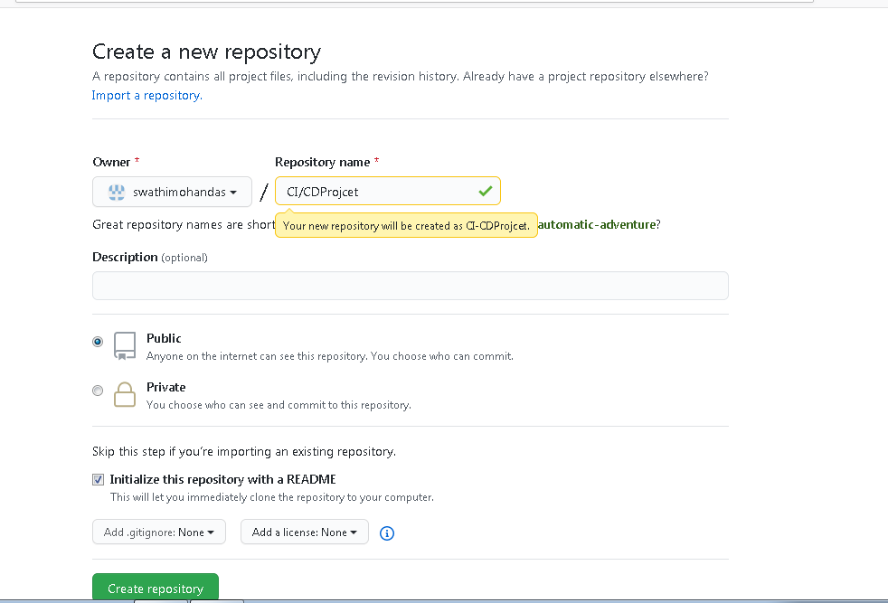

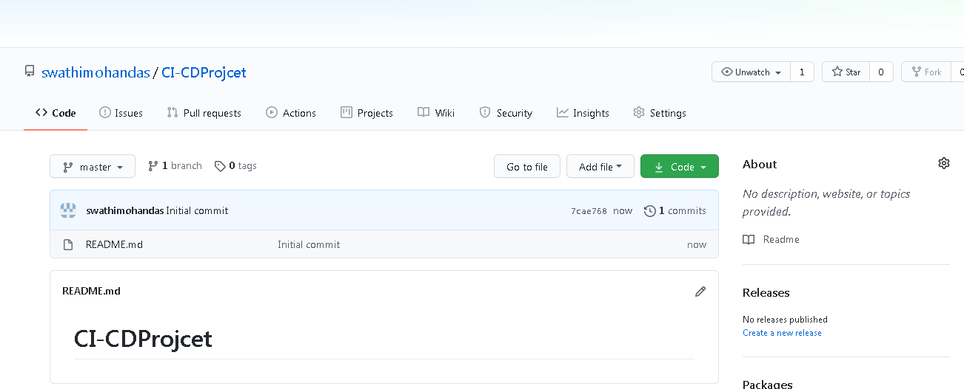

Now we will be creating some files in our local and will be pushing the files to the newly created GIT repository in GIT Hub.

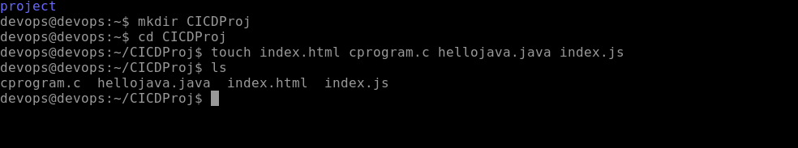

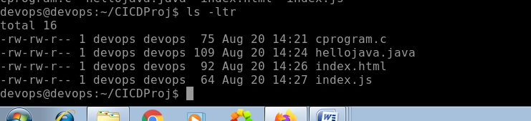

We have edited the programs

Login from GIT Local to connect remote github.

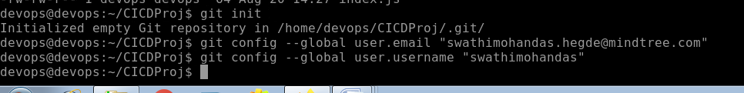

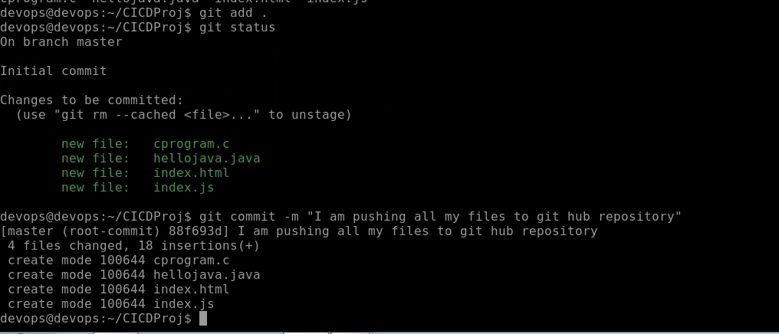

Now we will be pushing the files to git hut respository.

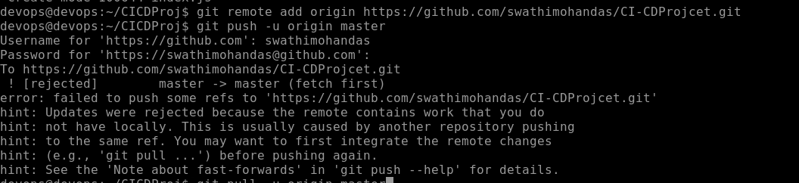

Since it failed we will execute below commands,because the GIT repository had readme.md as well which is not available in our local machine.

So Now we will be pulling the files from GIT repository to our local machine.

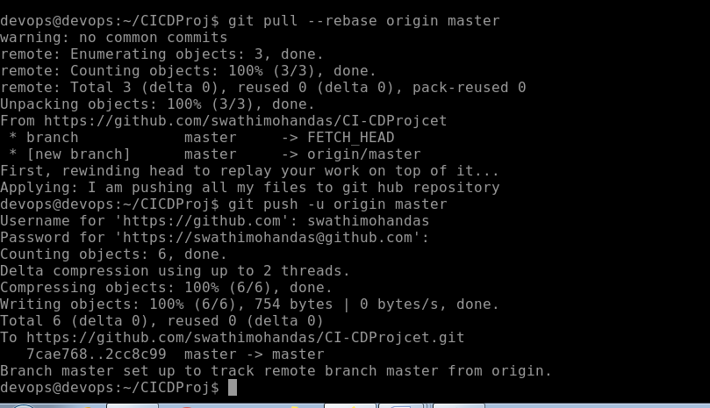

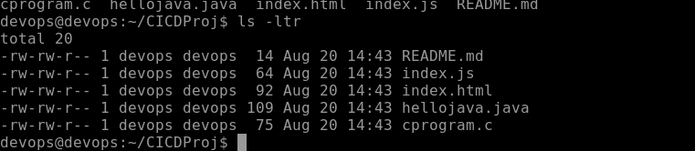

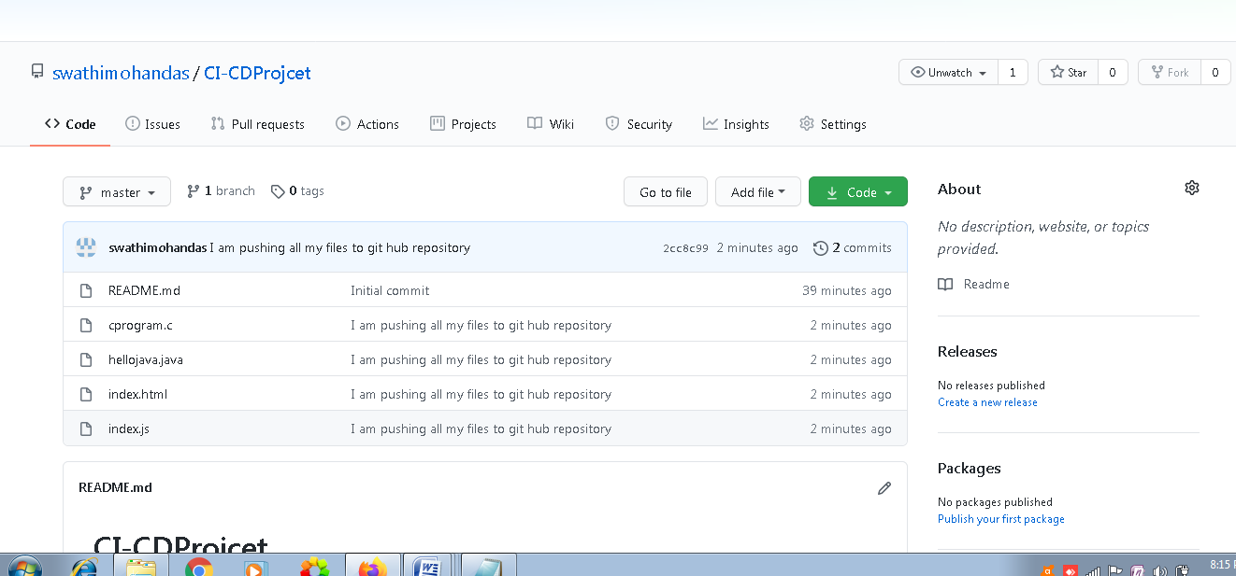

We could see that the files have been pushed to the newly created repository.

Now we will be creating branches DEV & QA

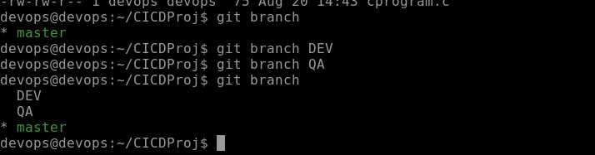

Git branch will list out all branches

The * shows in which branch u are currently in

To go to DEV branch we need to execute git checkout DEV

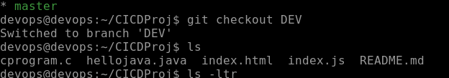

Similary to switch to QA we can execute

Git checkout QA as follows

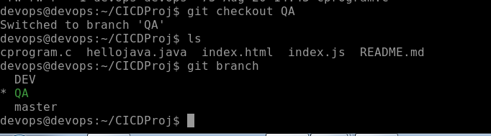

Now we will be making changes to the code in DEV Branch

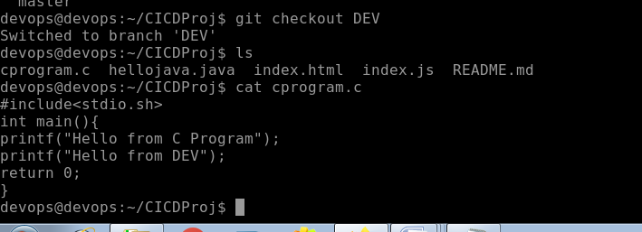

I have made changes in the DEV Branch fro cprogram.c

I ll be commiting the changes and then with switch to QA branch

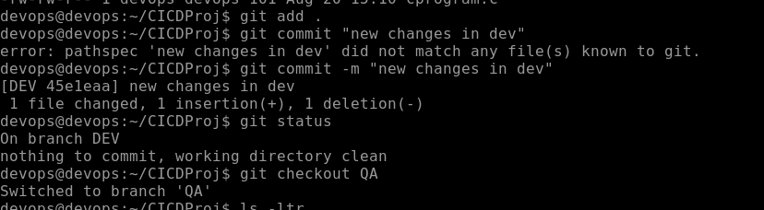

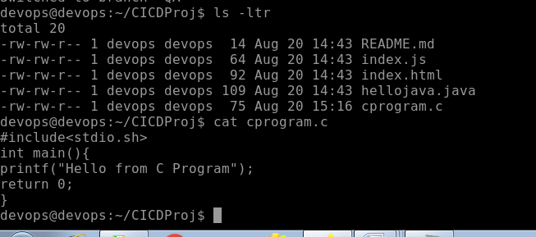

Both the branches have different code

Now we will be editing the cprogram.c in QA Branch .

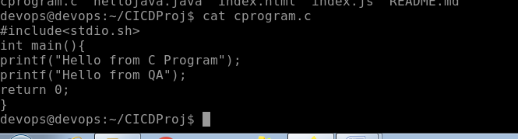

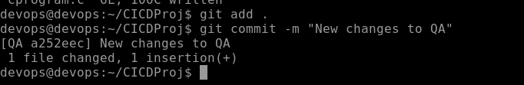

Switch to master branch and you could see that whatever updates made for cprogram.c in DEV and QA are not present in Master Branch.

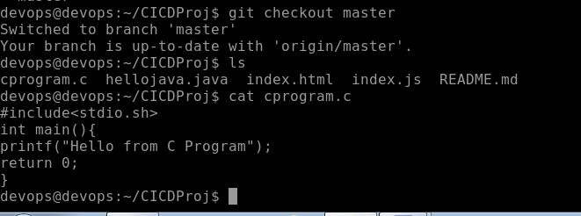

For that you need to execute merge commands

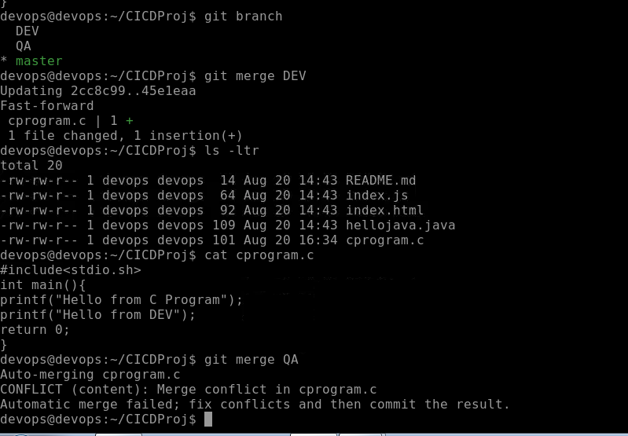

Since QA and DEV Branch both had changes in the same line there was a Merge conflict.

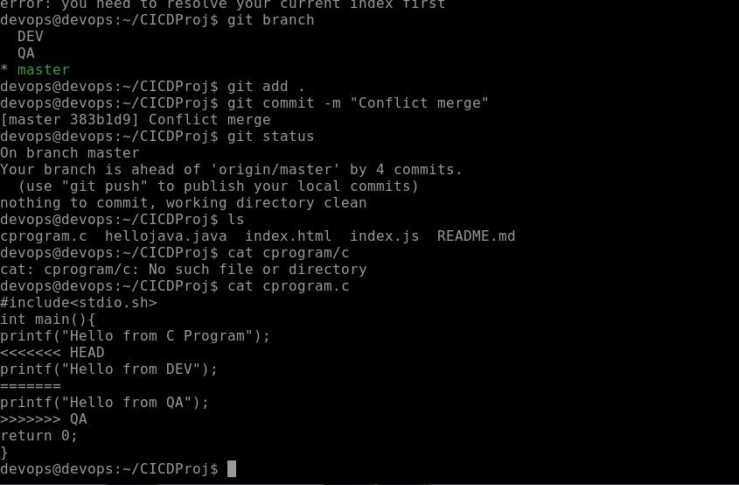

Now I will be deleting the conflict markers

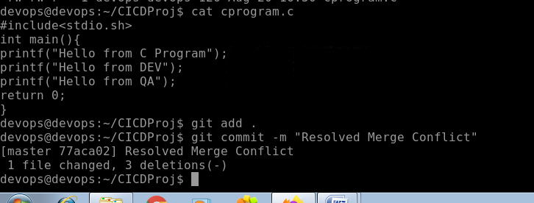

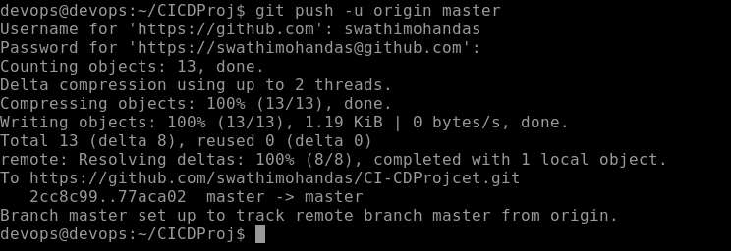

Now we could see that the edited file have been pushed to GIT HUB Repository

